Class and Objects:

Create class, then one main method is mandatory- that is the entry point.

Create objects - new Demo1(), new Dem01()… n no of .. and assign it to variables. Screenshot with example below.

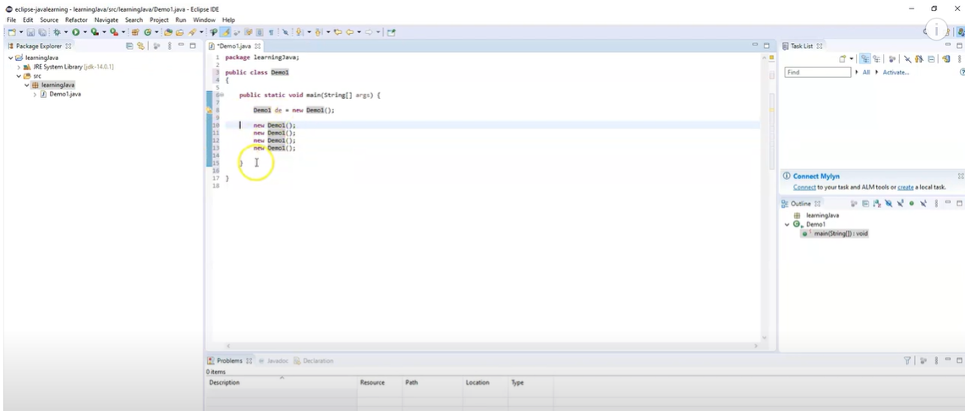

Best practices for naming convention below- not mandatory but a recommendation to follow these camel casing conventions.- but this is best practice and person going through your code will know that you know the basic concepts well.

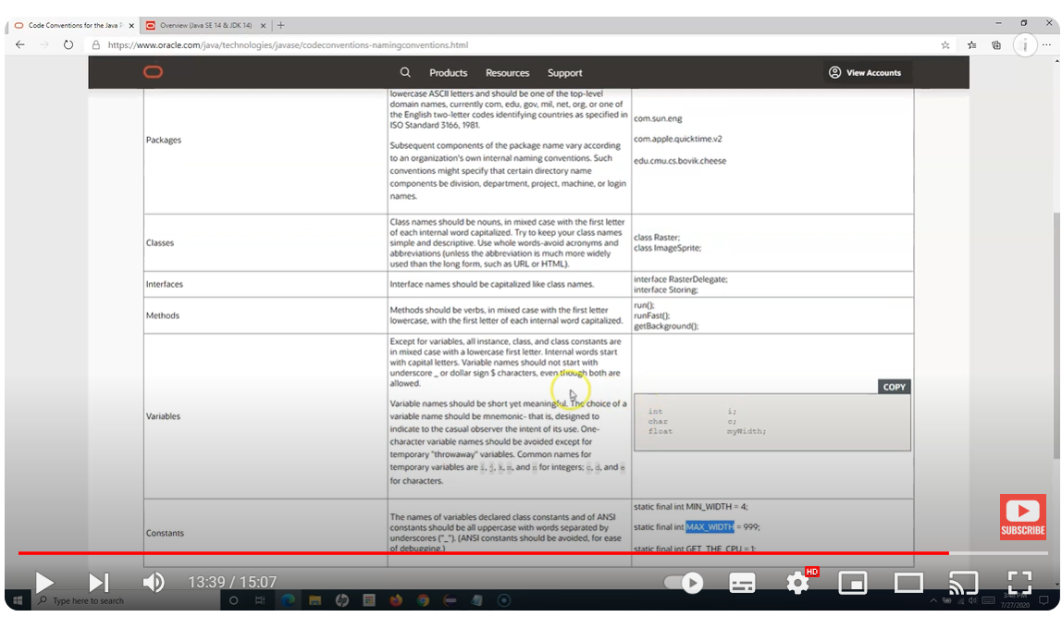

Single line and multi line commenting

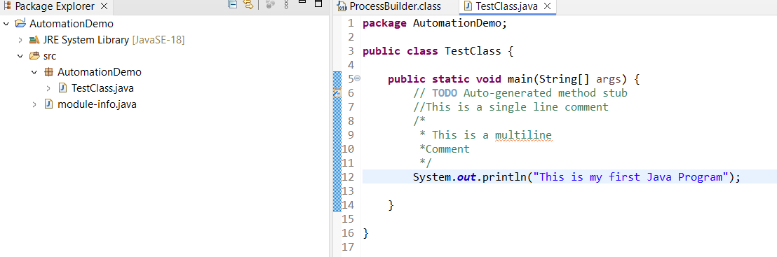

Data Types: Primitive below- these data types are already inbuilt.

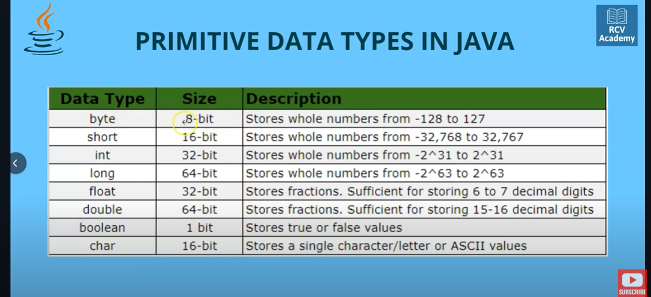

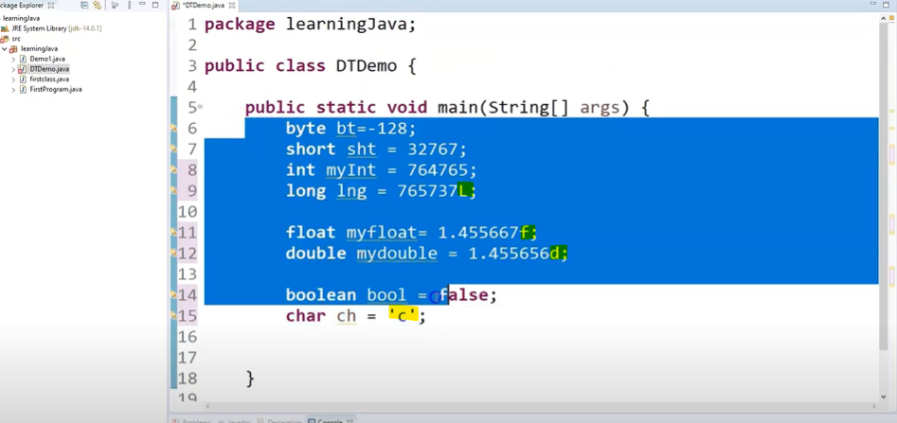

Non primitive data types- string and arrays

Non primitive data types are defined by the person writing the script.

DTDemo is a datatype here . Highlighted below.

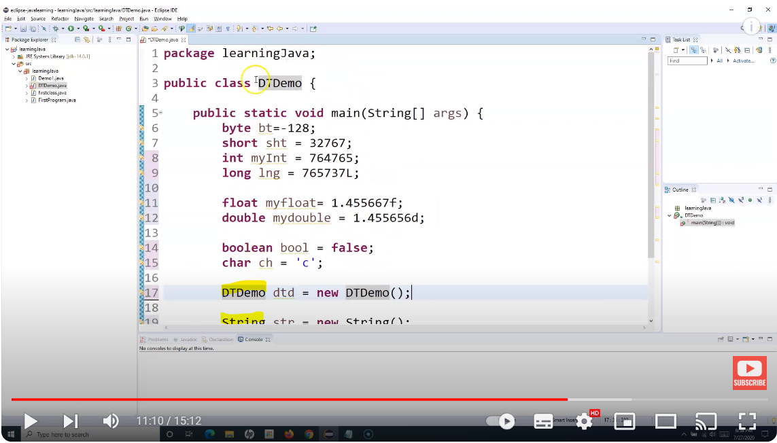

Difference between String literal and strig Obj- imp interview question.

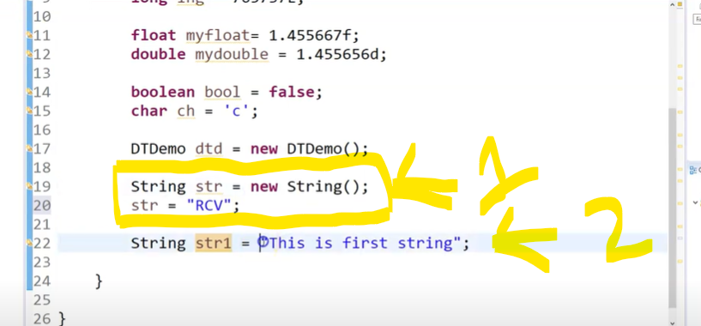

Abov pic 1- creating a new object of a string class and assigning it to a variable then assign value to that sting variable.

2- Directly assigning value to string variable without creating an object.

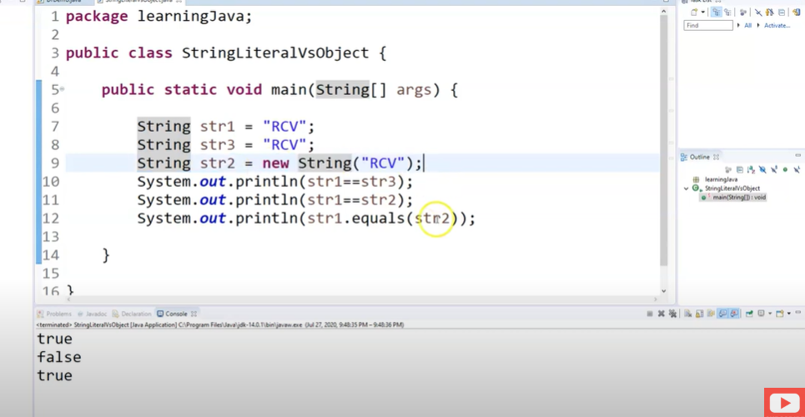

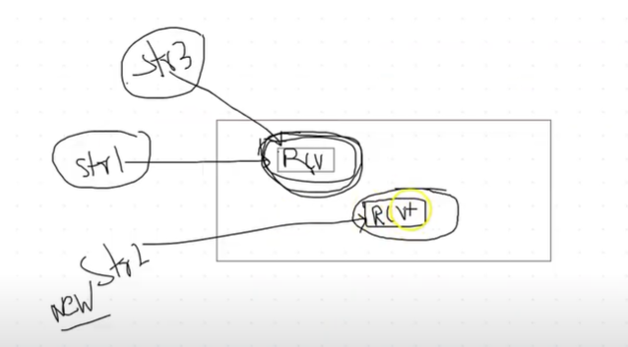

Str 1 and Str 3 is String literal.

In the JAVA memory heap- Str1 is assigned a memory location.

Then Str 3 is pointed to the same memory location as Str1 because the same value RCV already exists.

Since Str2 is string object, a separate object is created and memory is assigned in a different location of the heap.

As a result when we use the equals==operator to compare str 1 and str 2 , it returns false. Instead if we use the .equals method to compare it will return true because it compares the values stored inside each location and not just the location.

This is very well explained in the above 2 screenshots.

Note: Most of the times we use string literal. String object is rarely used.

JAVA Variables- container which holds the value that is used when the program is executed .

Types of variables:

1. Local variable- defined within a particular method.
2. Instance variable- variable defined within a class and not within a method.- if you want to use this variable, we can’t directly use this. We need to create an object/instance of the class and then use this variable.
3. Static variable- covered in advance concept.

String Concatination

TBC……………………………….

JAVA OPERATORS:

If else statement:

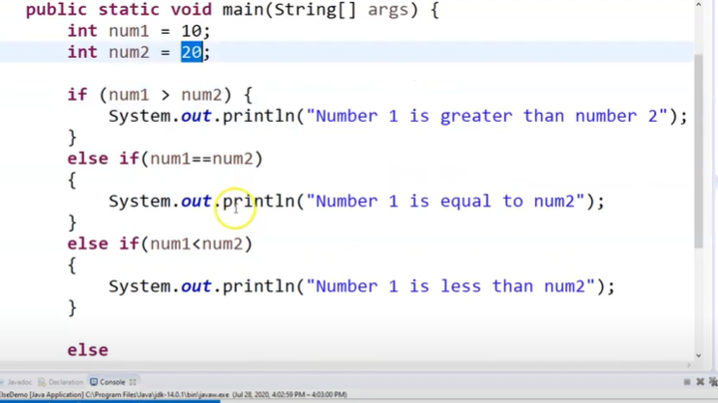

Nested If else:

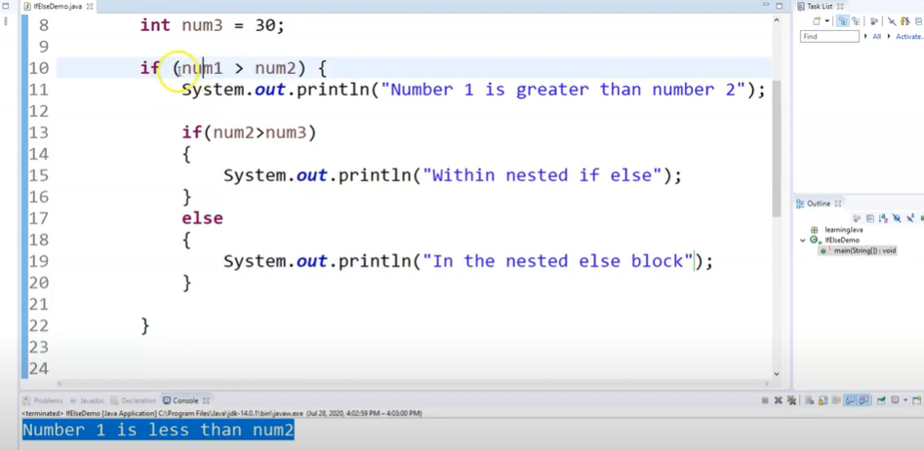

Ternary Operator: Shorthand for If else.

Entire if else code can be written in one line of code.

Syntax in below screenshot. Note: The variable is of data type string because the true and false expression we will be printing is string. Similarly the data type can be int/Boolean etc depending on the true and false expression/output that we will be printing. Refer the second screenshot for int.

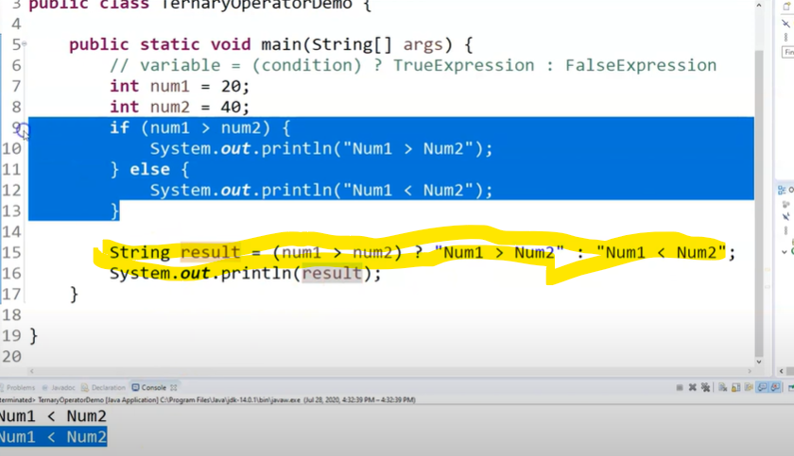

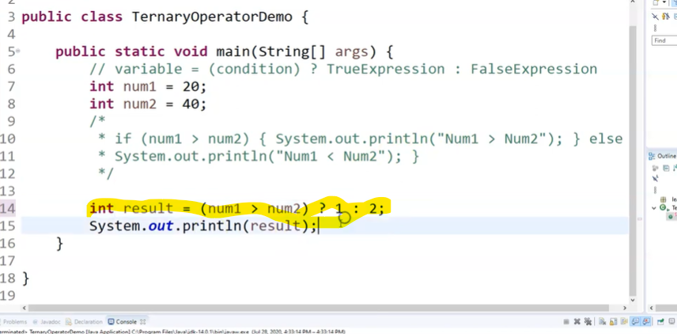

JAVA Switch statement:

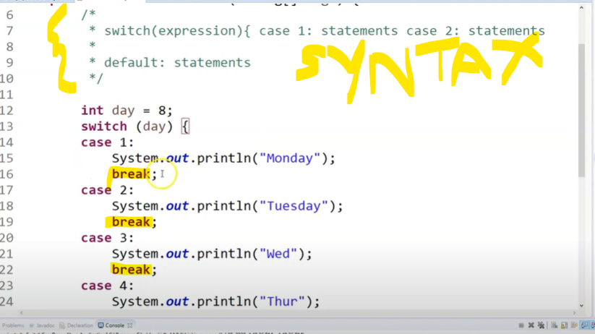

Here break statement in each case is important because we do not want any result to be printed other than that particular case that meets the condition.

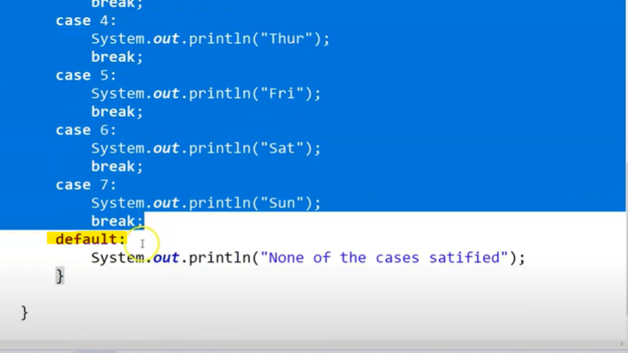

WHILE Loop:

Can also use true/false for a condition.

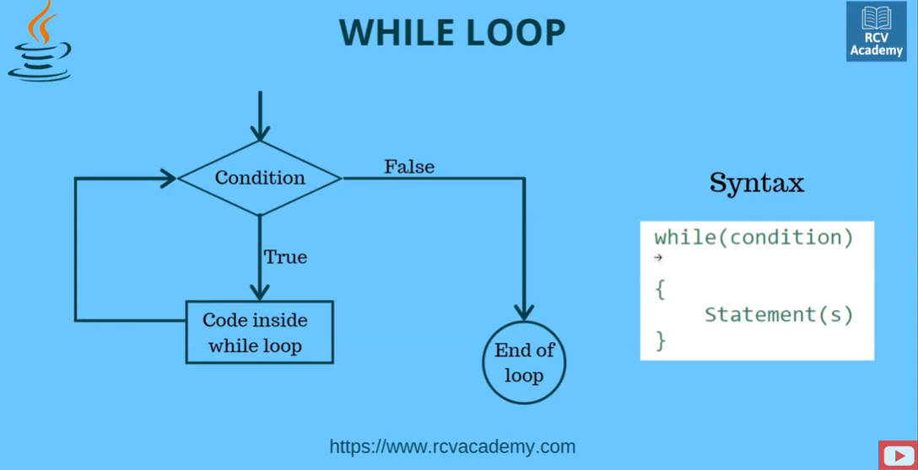

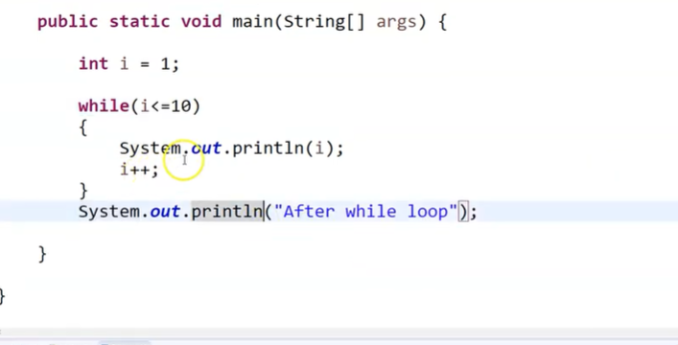

DO WHILE loop In Java:

The statements in the do while loop will be executed atleast once and then the condition is checked.

BUT- IN WHILE loop, first condition is checked and only if cond is true, statement is executed.

Diff between while and do while interview question.

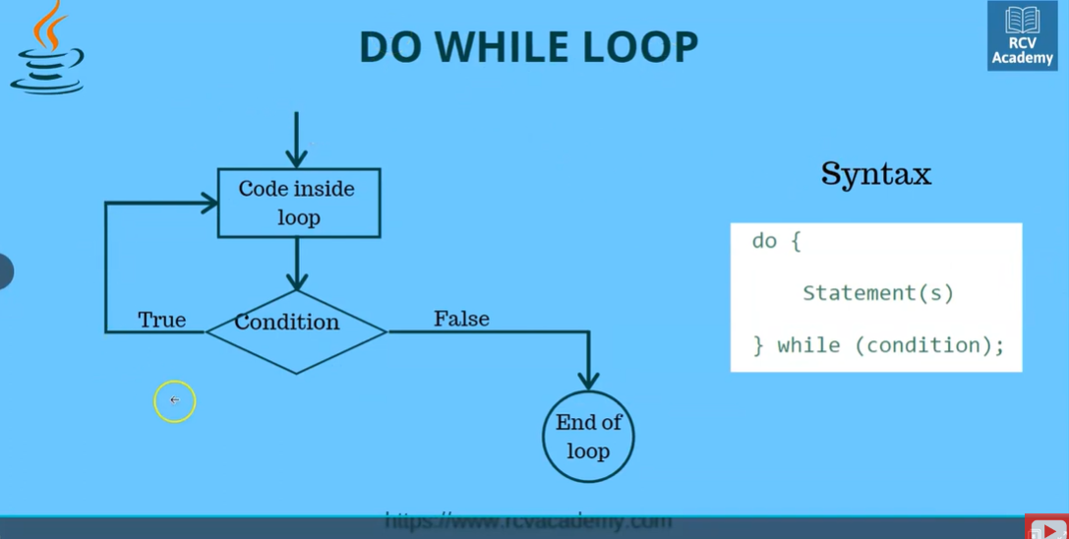

FOR LOOP: TBC….

Nested loops: TBC……

Arrays in Java:

Single dimensional array:

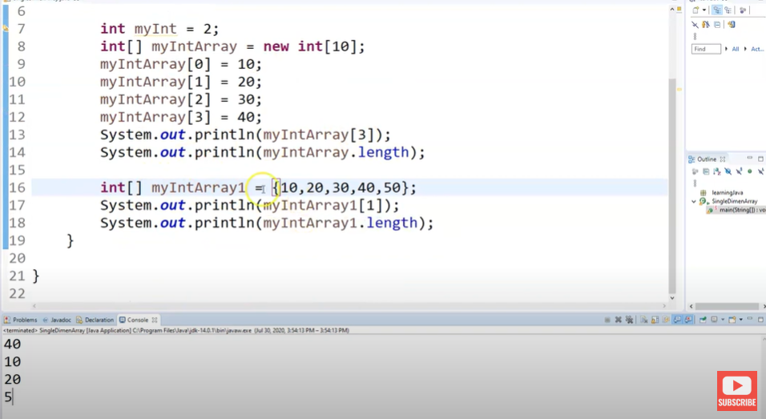

Can define different array types other tham Int data type too as follows:

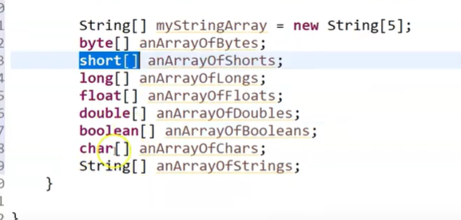

For loop for printing single dimensional array values.

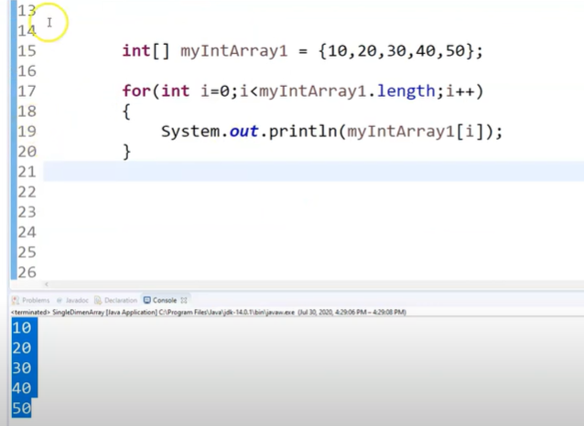

Multi dimensional array: It is an array of arrays.

Below picture with array size[2][3]

Here the size of array is 2\*3=6. Wchich is nothing but 2 times 3 . so 1 array with index 2 and 2 arrays with index 3.

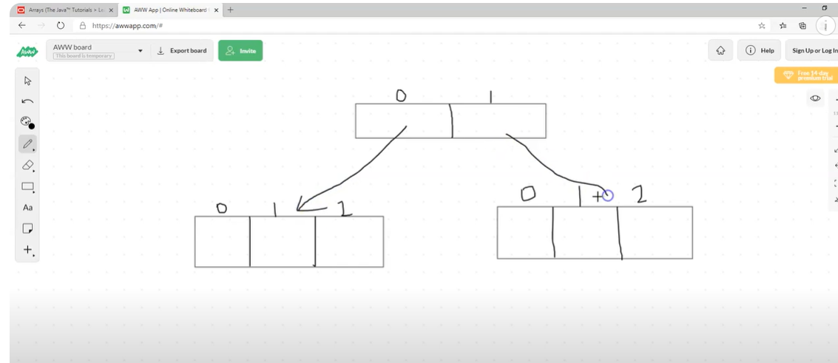

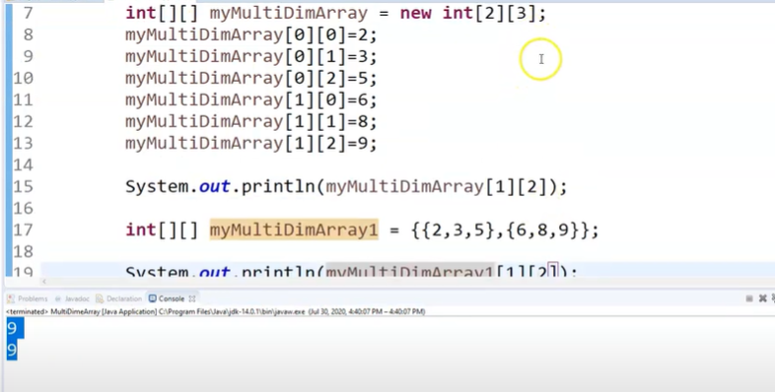

Nested for loop for multidimensional arrays:

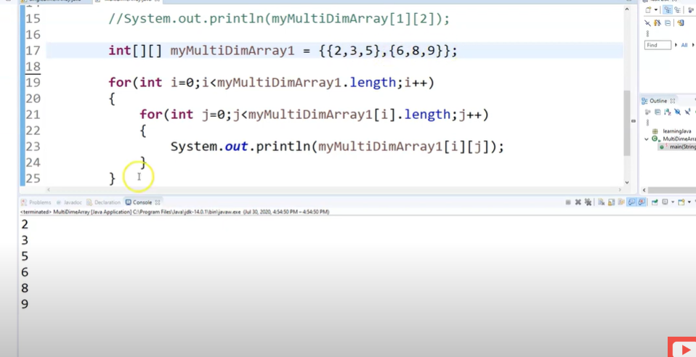

JAVA METHODS also called as Functions- very imp in selenium .

Any repetitive task is created and used as method. For ex: log in code. Can’t log in each time all over again to test all the test cases.

Use of method is to reuse the code.

It is nothing but a block of code that only executes when I call it.

Syntax:

public void doLogin()

{

//log in code.

}

In the above code we have mentioned void because return type is void. We give void when it is not returning anything.

Similarly, the return type can be int string etc and code will be as follows.

public String doLogin()

{

//log in code

return”abc” ;

}

* Methods can be called in main method by creating an object of the class as follows.

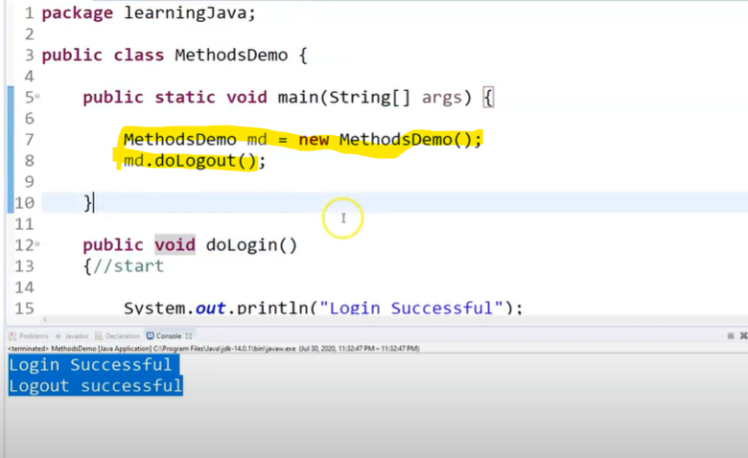

What are parameters and arguments in a method and how to use them.

Below highlighted the parameters of the method.

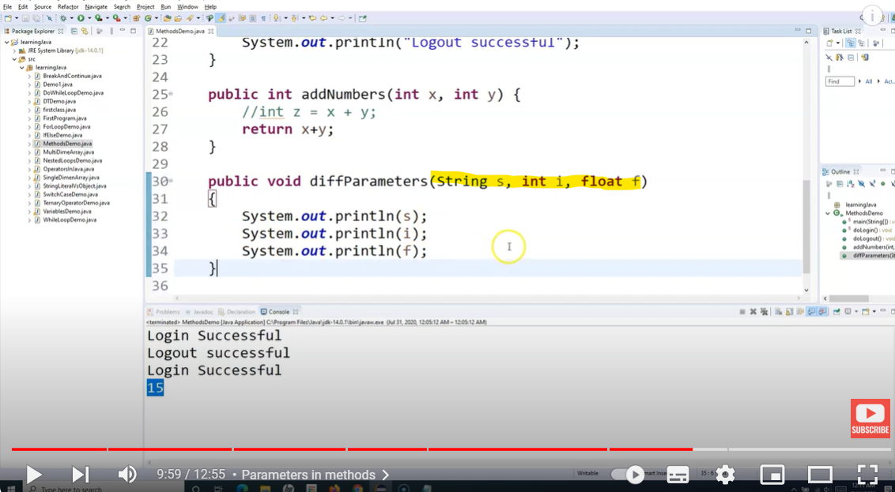

Then we need to call this method in a main method.

We first need to create an object of the main method to call this method- diffParameters because the method diffParameters we have created is not a static method.

The below highlighted values are arguments of the method- arguments are provided when we have to call the method.

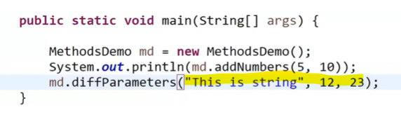

JAVA Packages:

Grouping of related classes and interfaces.

Significance: restrict access/ providing the access protection- access modifiers.

There will be different classes inside a package and different methods defined within those classes. If I want to use a method defined in any other class within the same package, we can do so by creating an object of that class(within which the method exists) and then calling the class through that object.

BUT if I want to use a method defined in a class within a package(ex: learning Java) to a class defined in another package(ex: Package A) then I need to first import that particular class and that package to my current Package- A and then create an object of that class – Demo1 and then call the method.

Example below. Highlighted .

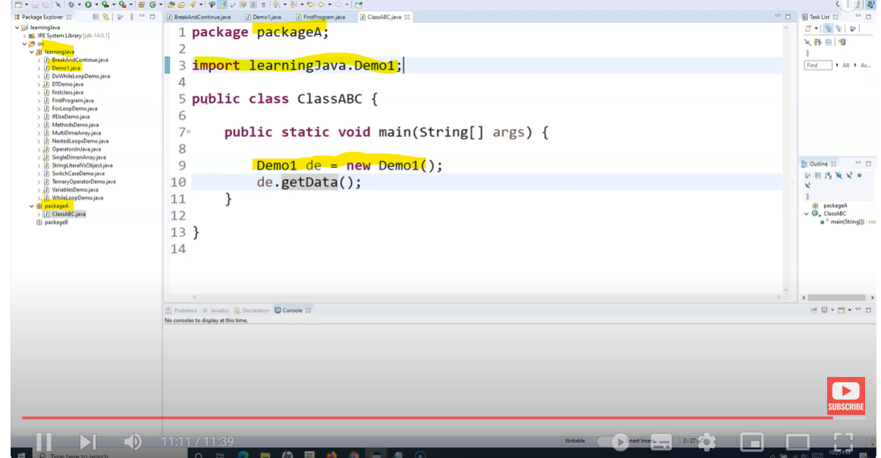

ACCESS Modifiers:

These are used to control the access to the members of the class. For ex: methods or data types or class itself.

There are 4 access modifier at VARIABLE and METHOD levels - public , default(when no access modifier is mentioned), private and protected.

If the access modifier for any variable or method is private it can only be called within the same class. It can’t be called in other classes though these other classes fall under the same package.

Methods and variables with only Public AM can be called in classes of other packages. Private, protected and default variables and methods can’t be called in other packages.

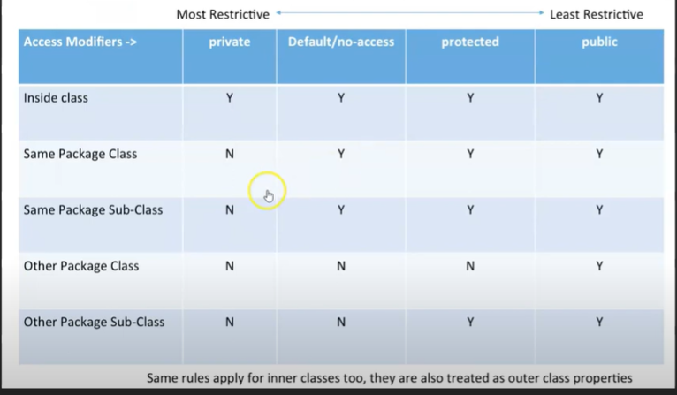

Note: A class can only have either public or default(no access modifier mentioned), private and protected not supported.

1. If the access modifier of any class is PUBLIC then methods in that particular public class are accessible to classes in other packages too.
2. But if the access modifier of the class is DEFAULT then the methods are accessible to classes within that one particular package class only.

Note : At the CLASS level there are only 2 access modifiers- Public and Default.

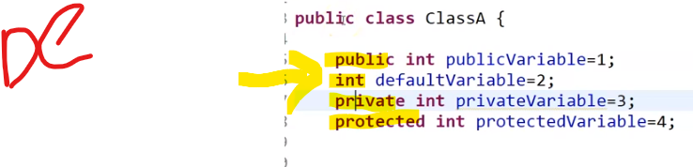

Encapulation:

Wrapping of data under a single unit.- secure the data within our class and methods.

1.- define data as private-

Set and Get data- setter and getter methods.

Ex: trying to develop a game.- when you don’t want to provide invalid values- with encapsulation set and get methods we can have logic to set and Get data.

Advantage – hiding the data- using private. And Reusability- .- imp for selenium.

Java Inheritance and Types:

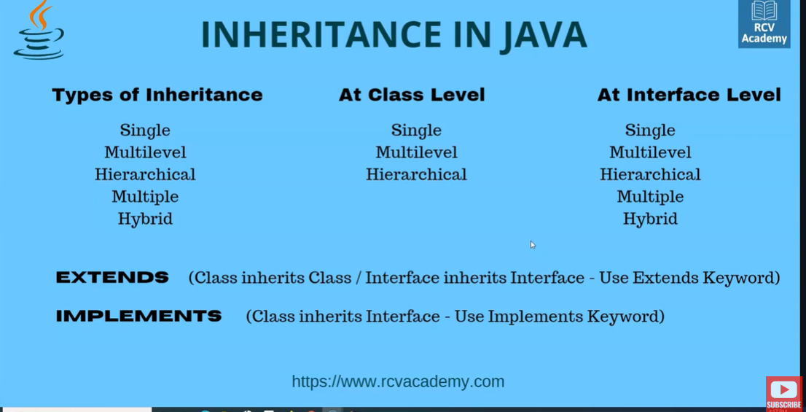

Vehicle- Truck ---- Single Inheritance.

Vehicle- Truck- Inveto- Multilevel Inheritance.

Vehicle--- 1. Truck, 2. Car- Hierarchical Inheritance.

Multiple and Hybrid not used for selenium automation.

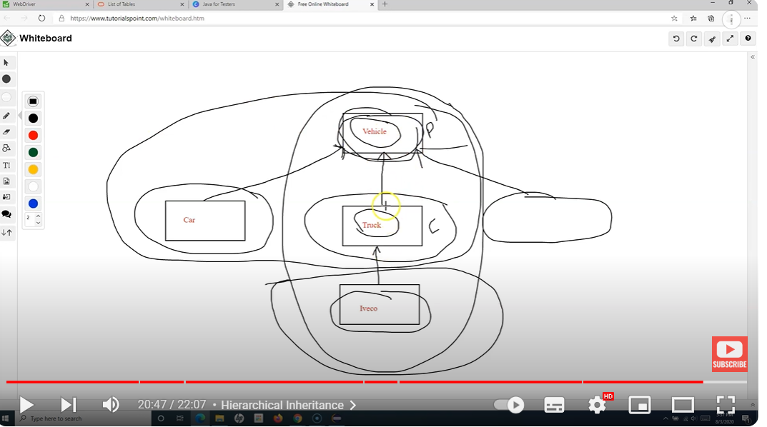

POLYMORPHISM:

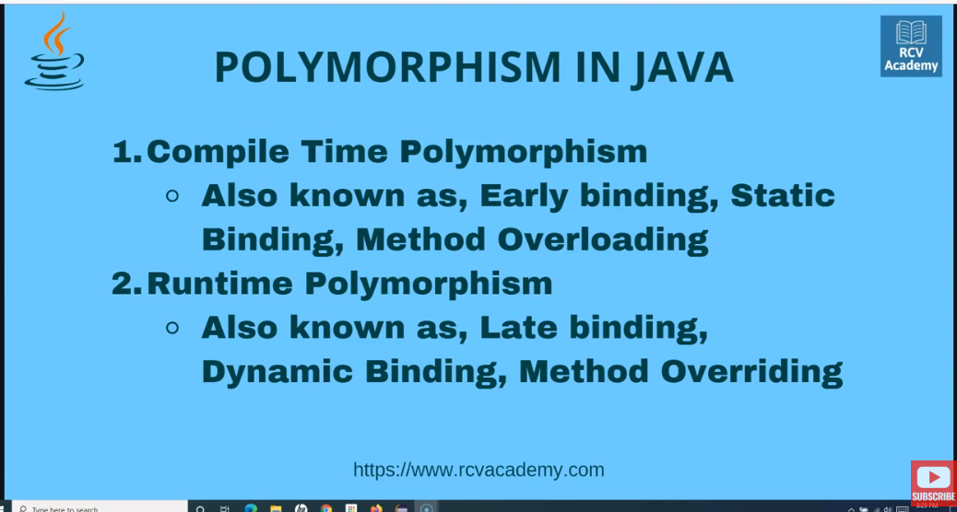

Method Overloading- same method with diff method signatures. Ex: log in to an app with username password, log in with phone and password , username otp etc.

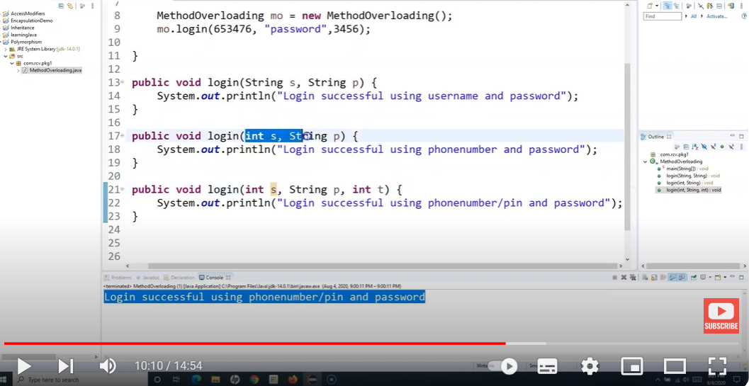

Method Overriding:- Method name needs to be same- parameters/method signature also needs to be same.Method Overriding/Runtime polymorphism is possible only when inheritance is there.

Ex: If there is a parent class- Animal with method make noise in it(prints animal makes noise)

A child class- Cat which extends Animal class and make noise method is called from (Parent class), the o/p printed will be Animal makes noise. But now we are in Cat class and we want something specific there like Cat meows or something. So in that case, we can create the same method again within that child class Cat that prints Cat meows. This way the existing method- makes noise() from parent class is overridden by the makes noise method in child class and the O/p can be overridden.

Imp Rules for overriding: 1.Method must have same name and parameters needs to be same as that of Parent class.2, Inheritance is Must(Is relation is must)- Overriding can be done in child class

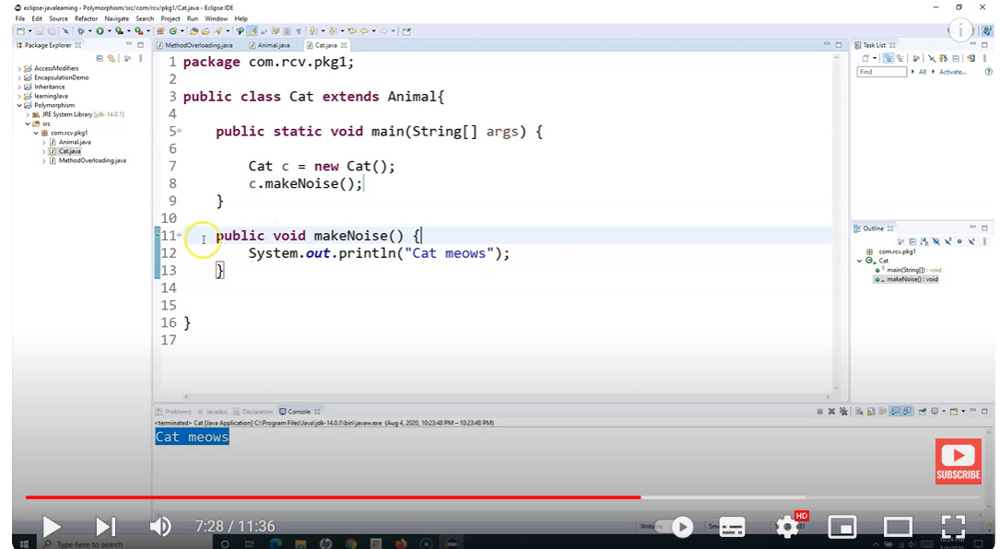

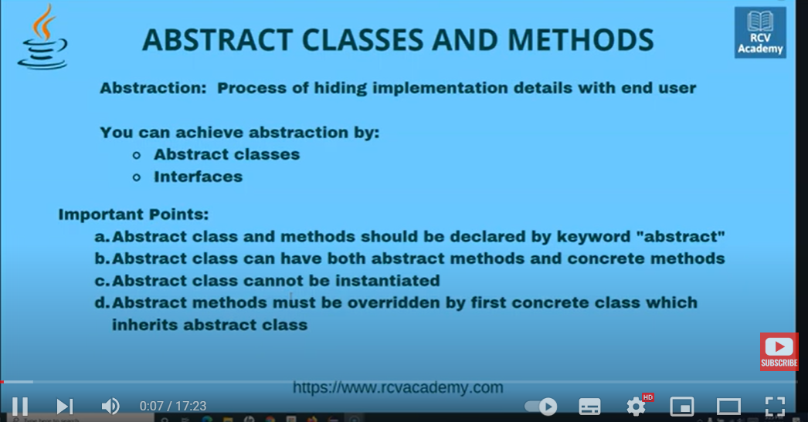

ABSTRACTION: Method of hiding the implementation details with the end user.

Abstract classes.

1. Abstract methods need to be defined with abstract keyword.
2. Abstract methods cannot have method body.
3. The Class within which the abstract method exists that also needs to have keyword abstract. A class can have both abstract and non abstract(concrete) methods- (they are methods which have method body).
4. We define abstract classes when we are only aware of the generic functionality and don’’t exactly know how the o/p is expected. Ex: Shapes, Animals etcs.

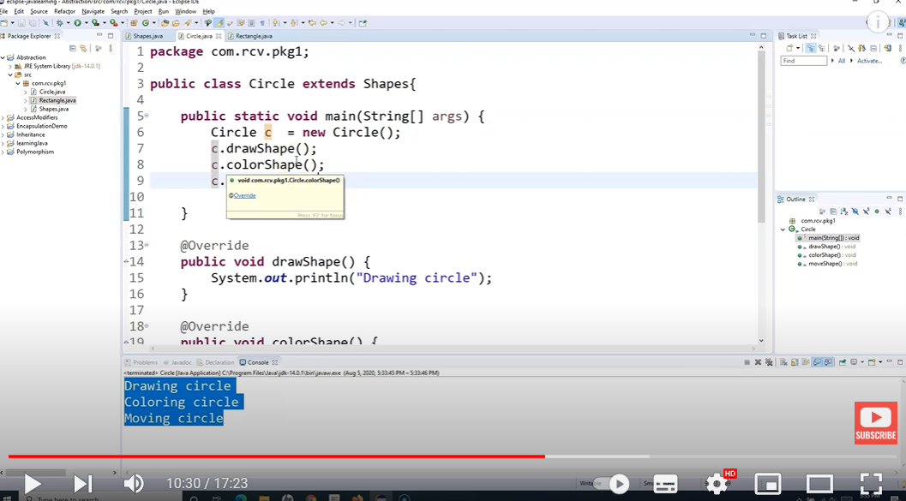

Ex Selenium- click method- we don’t know which browser – then define abstract classes.

1. Abstract methods cannot be instantiated.- If there is no inheritance. We create a object of the parent class in child class and call the parent abstract method in child class – its not possible. Throws an error.

INTERFACES in Java: We cannot have any concrete methods in Interface. – that is the diff between abstract class and Interface. WEBDRIVER is Interface in Selenium- all methods are abstracrt.

Constructors in Java: very similar to methods- they do not have any return type and name of the constructor is same as the class name. Constructors are used to create an instance of the class.

